Prediction of Diabetes Mellitus

Introduction:

Here while dealing with a neural network we discuss about the following concepts:

1.python programming

2.Artificial Intelligence

1.python programming:

Python is a general purpose , versatile and popular programming language. It is great as a first language because it is concise and easy to read and it is also a good language. To have in any programmer’s stack as it can be used for everything from web development to software development and scientific applications. It is a dynamically typed languages.

Python is a programming language with the following features:

1) Interpreted-Here the python will fall under byte code

Interpreted.

2) Interactive-There is interaction between the programmer

and the compiler.

3) Object-oriented-Python language is mainly focused on objects

and classes

4) Beginner’s language-Python is a simple and easily understandable language.

2.Artificial Intelligence:

Artificial Intelligence(AI) is the ability of a computer program of a machine to think and learn.It is also a field of study which tries to make computers “smart” .

The concepts involved here are:

1) Machine Learning(ML):

It involves 2 parts:

a.deep learning

b.predictive analytics

2) Robotics

3) Vision:This deals with image recognition and machine vision

4) Natural Language Processing(NLP):

It involves the following:.

a.Translation

b.Classification and Clustering

c.Information extraction

5) Expert System

6) Planning,Scheduling and Optimization

7) Speech:This deals with transformations either:speech to text or Text to speech

Objectives of the Project:

As the name implies, predicting diabetes mellitus describes the prediction of diabetes in a person.

So,the main objective is to make the correct prediction for a person who is effected by the disease.As a result the main emphasis is to avoid false positive case while predicting.

Problem Statement:

Diabetes is the most dangerous disease and became common in the present generation. There are different types of diabetes and it sometimes also occur during pregnancy. Most people know very little about the disease and the risks involved in it. As, avoid is better than cure , if the disease is detected at the earliest date, it can be avoided by taking the precautions. Our project will aid in this regard. It helps in predicting whether a person is diabetic or not. Besides the routine method of taking the blood sample and waiting for the test results, just by providing a piece of information, prediction can be done.

Review of Literature:

The project contains a user interface where he/she can interact with the system. user interface involves a form which need to be filled with the correct information of the patient.

The information of the patient involve the following factors:

1.Pregnancies

2.Glucose Level

3.Blood Pressure

4.Skin Thickness

5.Insulin Level

6.Body Mass Index(BMI)

7.Diabetes Pedigree Function

8.Age

the predicted output can be displayed to the patient which says his status on the disease that is if he/she is diabetic or not.So,in the background prediction is done with the help of Artificial Neural Network(ANN) by binary classification in it.

Data Collection:

The dataset for diabetes is taken from internet and the link is as follows:

<https://www.kaggle.com/uciml/pima-indians-diabetes-database>

The dataset contains 9 columns in which there are 8 independent values that are the factors that lead to the disease and 1 dependent value which tells whether the person is diabetic or not based on the independent values of that particular person.

we got to know more of the disease from the webpage whose link is as follows:

<https://www.webmd.com/diabetes/guide/risk-factors-for-diabetes#1>

<https://www.webmd.com/diabetes/guide/risk-factors-for-diabetes#2>

It explains about the different types of diabetes that occur and the causes and precautions to be taken for that particular type.

Methodology:

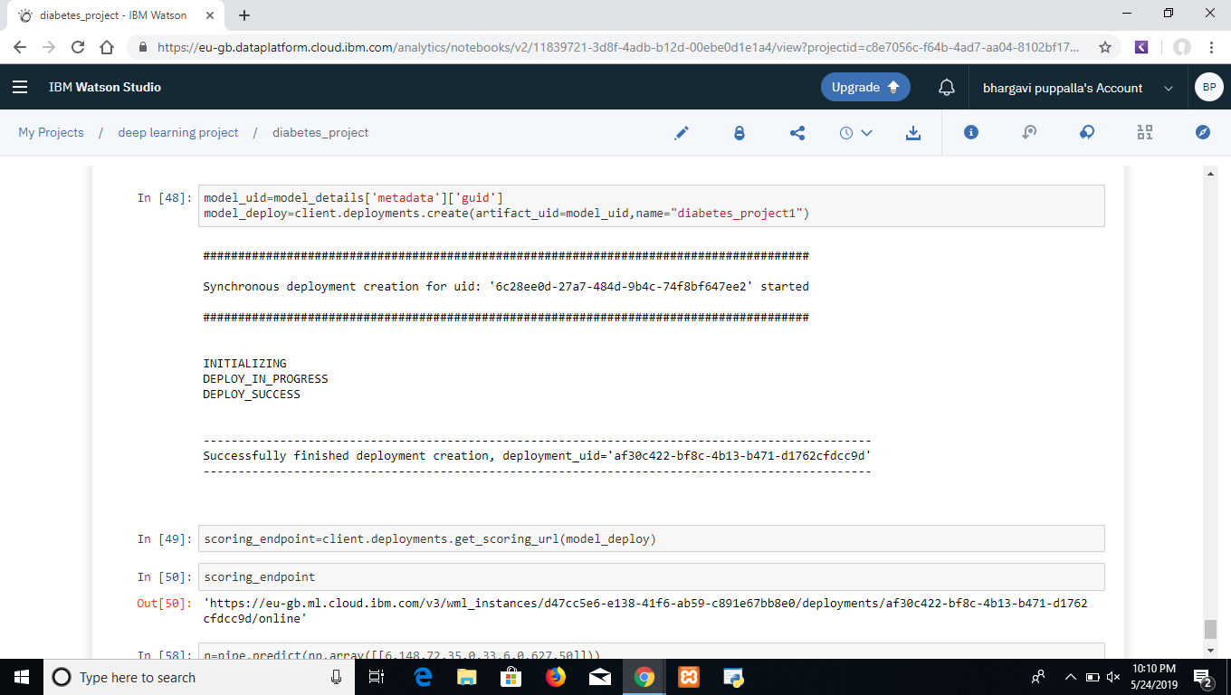

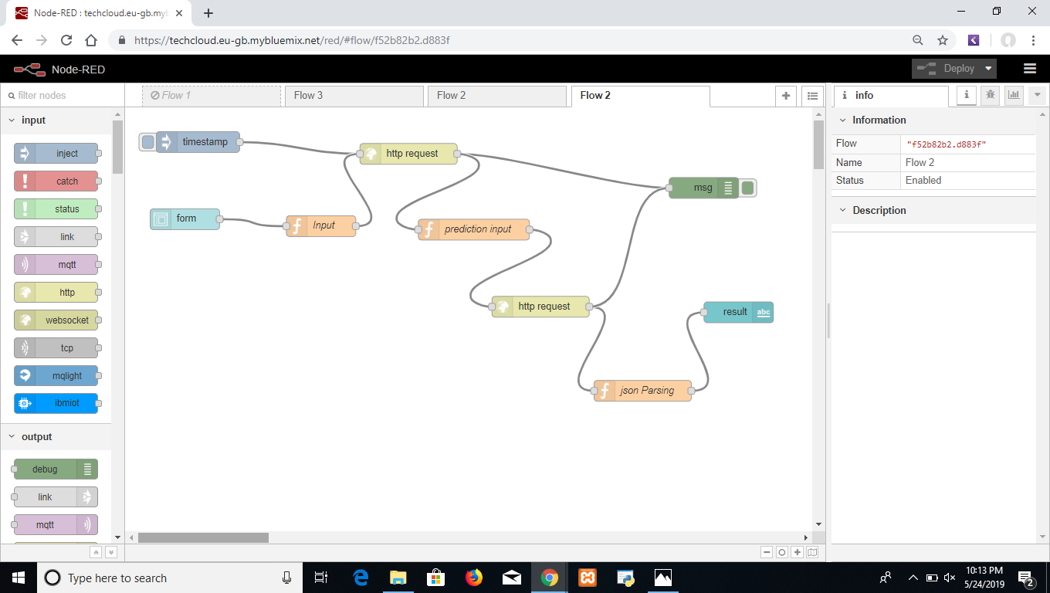

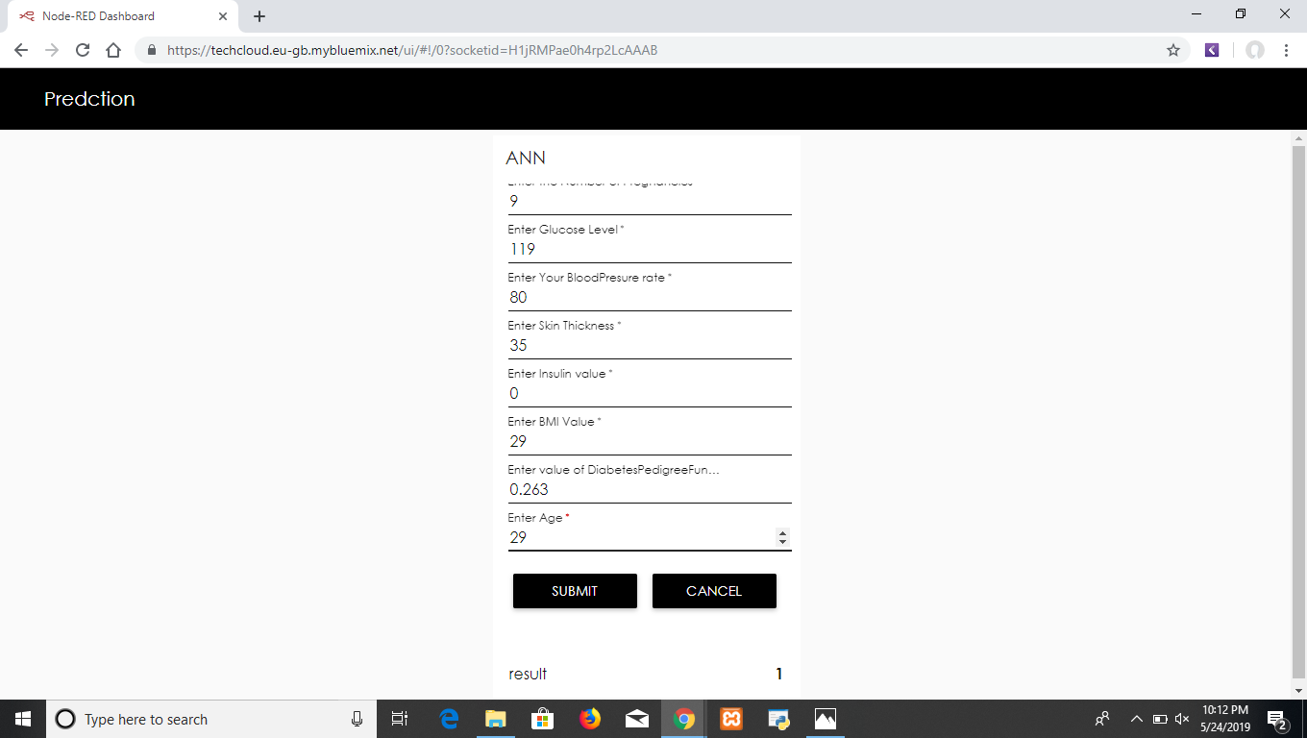

Findings and Suggestions:

It contains information about various sources, updations and suggestions of the project

The following are the links for more information about the project:

<https://www.hindawi.com/journals/jece/2011/681786/>

<https://www.researchgate.net/publication/267965137_Prediction_of_Diabetes_by_using_Artificial_Neural_Network>

<https://www.ncbi.nlm.nih.gov/pmc/articles/PMC2769804/><https://www.frontiersin.org/articles/10.3389/fgene.2018.00515/full>

Conclusion:

So, with the help of Artificial Neural Network(ANN) and python programming we are able to deploy the model where node red is the development tool in the IBM Cloud and are able to predict the Diabetes Mellitus in an individual.